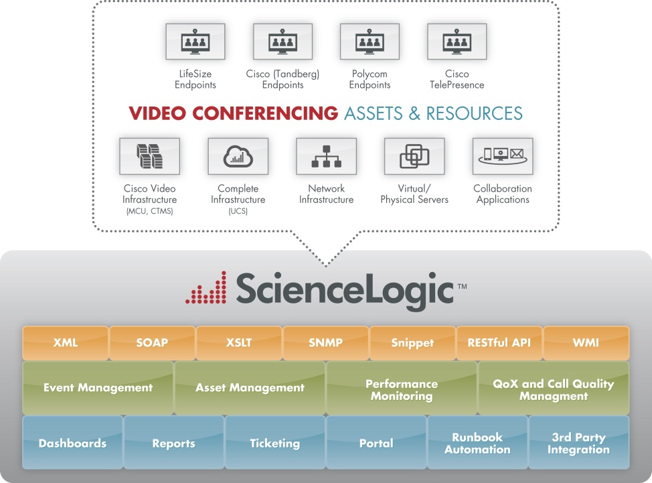

Automatically discovering all video conference and TelePresence assets on the network and applying the recommended monitoring policies for optimal availability and performance. Proactive management is essential to ensure QoS. The **ABC Company** video conferencing management solution builds upon our core IT operations management and monitoring platform and extends easily to heterogeneous, multi-vendor video deployments—to provide the most comprehensive Video Conference & Cisco TelePresence management solution on the market today.

**Proactively Monitor Video Conferencing & TelePresence**

In today’s global economy, relationships are more important than ever, requiring face-to-face communication with colleagues, partners and customers. Yet, new economic realities often prohibit travel schedules that are costly in time, resources and budgets. Video conferencing powers the new way of working where everyone, everywhere can be more productive with face-to-face collaboration through video conferencing solutions.

**ABC Company** can help you avoid service issues and interruptions, ensure your video conferencing solution is available when you need it, and police call quality. The **ABC Company** for Video Conferencing Management solution provides best practices management templates for proactive monitoring of all the assets and resources that comprise and support video conference service delivery—for the video infrastructure, the endpoints and the underlying IT infrastructure.

OVERVIEW

Best-practices monitoring for video conferencing endpoints: Cisco (Tandberg), Polycom, LifeSize, Cisco TelePresence

Auto-discovery of video endpoints with creation of asset records

Extensive reporting for availability, Quality of Service and usage

Near real-time and historical call quality reporting for trending and capacity planning

Single integrated solution for video and IT operations management

Video Conferencing & Cisco TelePresence Management

KEY FEATURES

**The ABC Company platform includes multiple management capabilities for seamless management of video conferencing, telepresence, and all infrastructure assets that support delivery of video and collaboration**

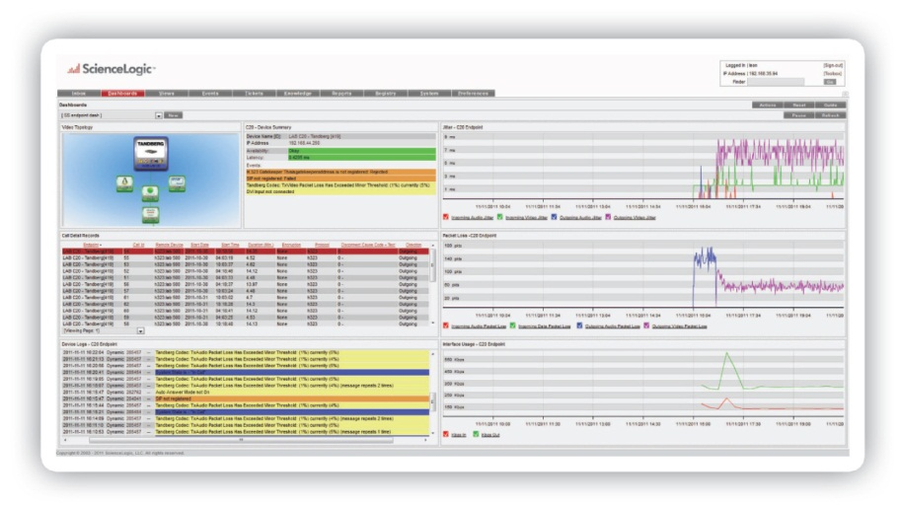

**Multi-tenancy**

Video service providers can use a single instance of the **ABC Company** solution and a single console in their VNOC to monitor individual customers whose data is kept secure and separate from others. Similarly, enterprise IT staff can take advantage of this multi-tenancy to monitor and manage video conferencing systems in different departments, business units, or geographies.

**Customization**

**ABC Company** provides a very flexible platform that can be tailored to meet your needs. Easy-to-use tools allow your engineers to do it themselves — set call quality thresholds, enable or disable events, change severity levels — and easily extend management to new video technologies and gear.

**Reporting**

**ABC Company** reports provide valuable information, including utilization stats that can be used to determine ROI. Sample reports:

• Usage reports

• Call Data Records (CDR) reports

• Call quality reports

• Availability reports

**Portal Capabilities**

Managed video service providers can easily create branded portals that offer each customer secure views into the operation of their own videoconferencing equipment and network. Furthermore, customers can be given the option to create and track tickets via the same portal.

**Historical Call Quality Statistics**

The call quality data is stored in the **ABC Company** central repository to enable rapid troubleshooting of problems after they have occurred. Additionally, the data is consolidated for trending, capacity planning, and service level reporting.

**Asset Information**

**ABC Company** provides an asset database that is automatically populated upon discovery and provides the capability to track assets, generate asset inventory reports, and validate the software release level.

**Configuration Monitoring**

The system retrieves the most important configuration data from the endpoints to enable quick troubleshooting of configuration-related issues. Sample configuration data collected includes:

• System Information

• SIP related information

• H.323 related information

• QoS, Call and Interface Settings

**Fault Management**

The **ABC Company** system monitors all aspects of the endpoints to ensure that the devices are fully operational and ready to participate in the next video conference. The system generates an event when it detects a problem. Sample events:

• Loss of communications to an endpoint

• Monitor disconnected

• Misconfigured Ethernet

• Camera offline

• Endpoint not registered to call control

(gatekeeper or SIP registrar)

• Call control services disabled

(H.323 and/or SIP service disabled)

• Abnormal call clearing

• Call quality threshold breached

FEATURES

**In-Call Performance Statistics**

While a video conference is active, the **ABC Company** system proactively monitors the call, collecting call quality statistics each minute and providing alerts when call quality drops below an acceptable threshold. Sample data collected includes:

• Packet loss

• Jitter

• Bit rate

When supported by the endpoint, data is collected for both directions of transmission as well as for all media streams — including video, audio, and presentation.

Copyright © 2012 **ABC Company**, Inc. …………………...

**ABC Company Dashboards provide summary views of availability and performance for video infrastructure, video endpoints and the underlying IT infrastructure**

**Video Conferencing & Cisco TelePresence Management**