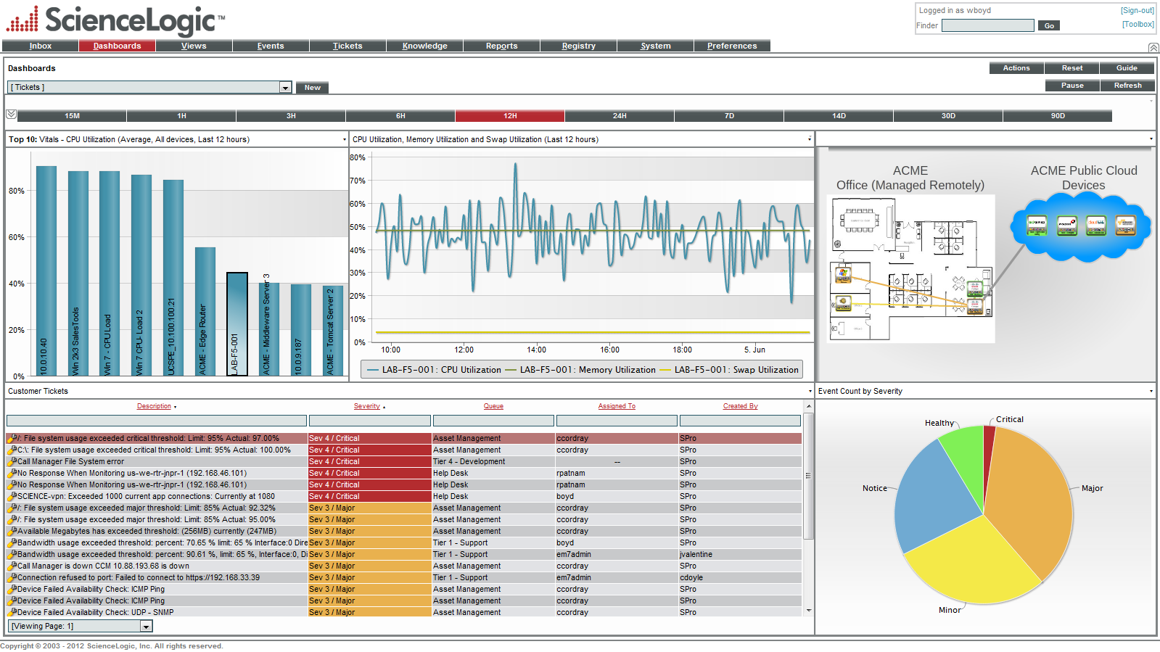

Unlike traditional stand-alone ticketing solutions, the **ABC Company** Service Desk is fully integrated with other platform features, so users always have access to the information they need to resolve incidents. Events (alerts) are triggered by syslog and trap messages, security parameters, user-defined performance, hardware thresholds and much more.

With a single mouse-click, incidents can be created in response to these events. When viewing or responding to incidents, users can view relevant system details and status, directly from the incident session. Metrics, reports, and historical data are included and make it easy to track trends, improvements, and productivity. Incidents will never get "lost" or forgotten. Automated incident escalation ensures that key staff are notified of important incidents and if they remain dormant for too long.

Service Desk

OVERVIEW

The **ABC Company** platform includes an embedded feature-rich Service Desk that enables staff to quickly manage tasks and track incidents within your environment. A strategic business advantage, the **ABC Company** IT Operations monitoring platform can increase operator productivity and efficiency significantly.

System architecture combined with unprecedented ease of use through a unified and secure portal, the **ABC Company** platform saves you both time and money. Integrated with other **ABC Company** embedded capabilities, the Service Desk system is the perfect solution for all your customer support, help desk or internal ticketing needs.

KEY BENEFITS

### Integrated Reporting

### 

### Policy Based

### 

### Escalations

### 

### Reduced TCO

### 

### Granular Access

### 

### Centralized Portal

### 

### Highly Customizable

### Incident & Problem Management.

### 

### Asset & Configuration.

### 

### Service Level Management.

### 

### Service Views.

### 

### Multi-Tenant.

### 

### HTML5 Dashboards.

### 

KEY COMPONENTS INCLUDED

FEATURES

**Rich Features**

Designed by IT Managers and hosting providers a robust set of features that previously were only found with high-cost enterprise ticketing solutions are included.

• Create incidents based on events, email messages, phone calls and manually.

• Automatically generate tickets if specified conditions are met.

• To streamline workflow email notifications to users are automatically populated with ticket details.

• A "roll up" feature groups multiple occurrences of an incident under one ticket.

• Events can be aligned with a single ticket, so users can see relationships between events.

• Users can view information on event history, ticket history, devices, and organizations directly from the Ticketing session and add comments and attach files to tickets.

**Ease-of-Use**

The **ABC Company** Service Desk includes features to simplify incident and task management and help reduce the learning curve for your staff:

• Incidents can be created from events with a single mouse click with many fields automatically populated.

• Reduce "user error" with automated ticket escalation and automated ticket resolution. These automated features and remove the need for ticketing maintenance, freeing up staff for more important tasks.

• Incidents are color-coded for quick identification.

• Includes both single-click searches and sorts and sophisticated regular-expression-based searches and sorts so finding a specific ticket is always easy and painless.

• When a ticket is assigned to a user a notification email is automatically sent to the user

• Your customizable dashboard provides an overview of activity for the last 30 days, including severity of each ticket and the average resolution time.

**Increased Productivity**

Increases productivity with the intuitive and flexible service HTML5 portal, which allows users to quickly access the specific information they need to get their jobs done. Analysts are never inundated with extraneous information or exposed to other groups' confidential information.

• Each user sees relevant tickets only. Ticket Queues are fully customizable and defined by your administrators.

• Tickets are assigned to organizations defined by you. By default, users with user-level accounts will see only tickets assigned to their organization.

• Each ticket includes a cloaking option, which prevents unauthorized users from viewing comments and file attachments.

• Key Privileges allow help desk analysts to define who can view tickets, what information can be viewed, who can create tickets, and who can edit tickets.

• Fully-customizable Account Template allow analysts to finely tune these parameters, by group or by individual user. The Ticketing Reporter creates highly detailed and flexible reports based on any combination of any ticketing properties, including date, severity, device, status, queue, and user.

Copyright © 2012 **ABC Company** ,

**Service Desk**