{Your Company Logo} |  |  | Managed Conferencing Service
Overview  In today’s global economy, relationships are more important than ever, requiring face-to-face communication with colleagues, partners and customers. Yet, new economic realities often prohibit travel schedules that are costly in time, resources and budgets.  Video conferencing powers the new way of working where everyone, everywhere can be more productive with face-to-face collaboration through video conferencing solutions.  Powerful yet affordable.  The {Service Name} complements, rather than replaces, the tools you depend on to manage your Video deployments. It is designed to work the way you need to, with remote access and better control and visibility into your Video  - Common user experience platform  - Intuitive {Service Name} Portal  - Dashboard with status of customer environments  - IT assets inventory and assessment  - Monitoring, alerting, and reporting |  |  | Video Solutions: Telepresence, HD video conference systems, Infrastructure, Providea Presence™, Tandberg (Platinum), Polycom, LifeSize,  Conferencing Services: Video, audio and Web conferencing  Network Services: Converged and overlay, ISDN Transport  (SDS), Routers, switches  Auto-discovery: of video endpoints with creation of  asset records  Historical: call quality reporting for trending and capacity  planning  Reporting : 24x7 Client portal with self-service reporting for availability, Quality of Service and ROI.  The {Service Name} service discovers video devices on the  network and displays the topology.  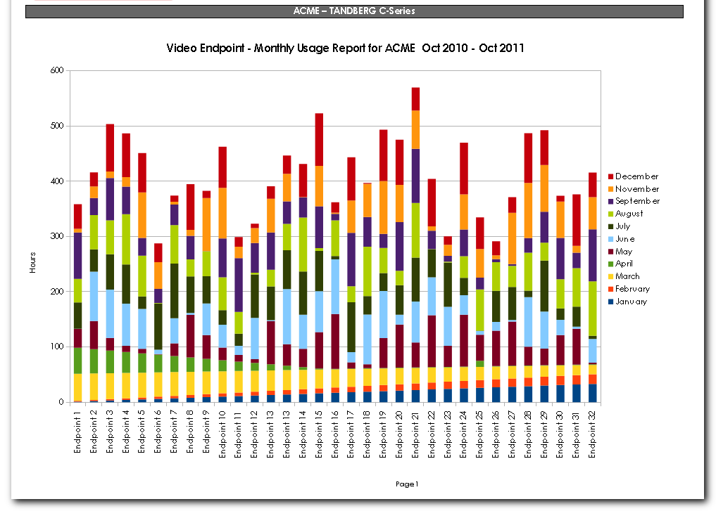 The {Service Name} service provides a complete inventory of Video infrastructure and endpoints in your network.
Activity | Basic Notify/Fault |  |  | Full  Monitoring | White Glove  Management
MONITORING
24/7 Up Down Monitoring of all Video Endpoints and Infrastructure (CTS, Tandberg, Polycom & Lifesize) | YES |  |  | YES | YES
Incident Detection, Recording and Reporting | YES |  |  | YES | YES
Automated Event Correlation | NO |  |  | YES | YES
Incident Notification | YES |  |  | YES | YES
Problem Identification | YES |  |  | YES | YES
Real Time Call Monitoring | NO |  |  | YES | YES
CDR Historical Monitoring | NO |  |  | YES | YES
Network Troubleshooting and Monitoring | NO |  |  | NO | YES
Remote Equipment Monitoring | NO |  |  | NO | YES
REPORTING
Online Standard Reports for Availability and Performance | YES |  |  | YES | YES
Monthly System Analysis Reports | YES |  |  | YES | YES
Schedulable Usage Reports | NO |  |  | YES | YES
CDR Reports | NO |  |  | YES | YES
Endpoint & Infrastructure Reporting | NO |  |  | YES | YES
Asset Tracking Reports | NO |  |  | NO | YES
Network Usage Reports | NO |  |  | NO | NO
CUSTOMER PORTAL
Custom Branded Portal for customers to access available via web or mobile | NO |  |  | YES | YES
Real – Time Dashboards showing fault, performance and usage across all devices | NO |  |  | YES | YES
Historical Dashboards show video usage, growth and help to identify potential problem areas | NO |  |  | NO | YES
HELP DESK
Web Based Help Desk for Ticket Creation and Tracking | NO |  |  | YES | YES
D:W:M Reports on incidents found and incidents fixed | NO |  |  | YES | YES
Access to Engineering support to diagnose and resolve incident | NO |  |  | NO | YES
24/7 Phone Support | NO |  |  | NO | YES
Management
Software Patch Level Reports | NO |  |  | YES | YES
Hardware Configuration Reports | NO |  |  | YES | YES
Software Patching | NO |  |  | NO | YES
Automated Incident Response Including Re-Starts | NO |  |  | NO | YES
Room Certification | NO |  |  | YES | YES
Conference Scheduling and Production | NO |  |  | NO | YES
Concierge Service | NO |  |  | NO | YES

{Your Boiler Plate}

