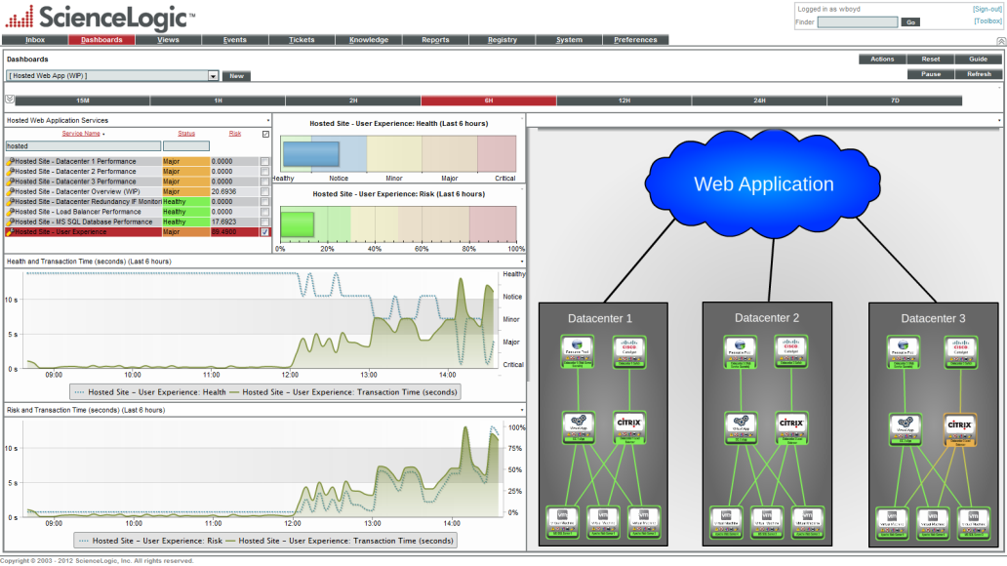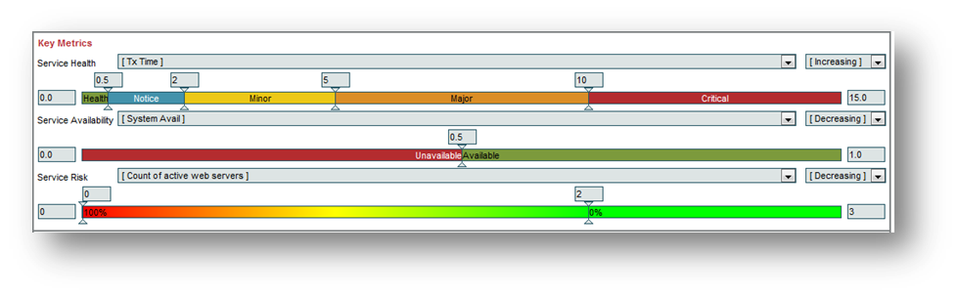

### **Service Model**: Group IT infrastructure and applications into a flexible, virtual construct representing the service.

### 

### **Service Monitoring**: Monitor the status of the components that comprise a service and apply rules to events from those components to represent service status.

### 

### **Service Reporting**: Identify problem areas and improve the quality of the service using dashboards and reports for continuous service improvement.

### 

### **Service Topology**: See how the Service is decomposed in a topology view you define.

KEY BENEFITS

The historical approach to Service Management consisted of managing the status and performance of the individual infrastructure components that comprise, support, or provides a service. “Tribal knowledge” (based on experience of the individual) provided an understanding of service impact if a part of the infrastructure failed.

There have been several approaches to Service Discovery and Dependency Mapping that range from discovering and modeling the layer 2 or 3 topology to packet inspection and agent-based discovery. The former is too “node-centric”, assuming a device supports only one Service. The latter is expensive and difficult to implement.

IT Operations often has to compromise between automatically discovering the Service model and creating a model that is useful to the way that they envision the Service. Flexibility is key. Automation is what makes it sustainable and scalable.

OVERVIEW

**ABC Company** Service Management provides a set of flexible capabilities to enable IT Operations to model services, monitor performance and availability of the service, and implement Service Level Agreements (SLA’s). Pre-built or custom dashboards provide summary service or group views of availability and performance for all the underlying IT infrastructure supporting your IT services.

Once the service has been defined the next step is to associate and measure that service via Key Performance Indicators (KPI’s).

To simplify measurement we have created 3 at-a-glance criteria:

• **Status**: Is the Service up or down?

• **Health:** How well is it performing?

• **Risk:** What is the chance it will fail?

IT Service Management

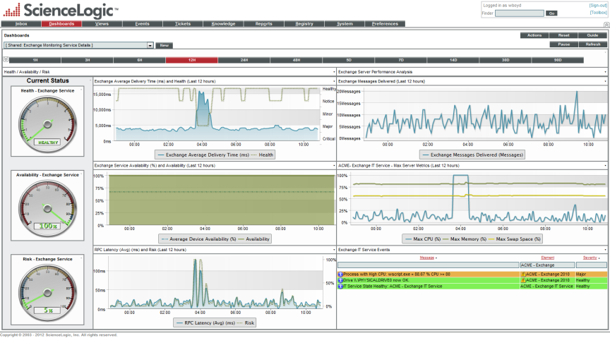

**Service Alarms**

The IT Service Desk is concerned with Service Delivery and the status of IT services they manage. The Service Desk needs alarms (and by extension, tickets) on these servicesinaddition to any ticket that may be created on the infrastructure that caused the incident.

**Service Level Agreement**

A very flexible option for calculating your SLA compliance. You are able to define compliance time periods and measure the status of that agreement with a color coded pre-defined simple to interpret widget in a dashboard.

FEATURES

Your Customer Testimonial

**Multi-tenancy**

Service providers and corporate IT admins can use a single instance of the **ABC Company** solution and a single console in their NOC displays to monitor individual customers whose data is kept secure and separate from others. Similarly, enterprise IT staff can take advantage of this multi-tenancy to monitor and manage services in different departments, business units, or geographies.

**Portal Capabilities**

Service providers can easily create branded portals that offer each client secure views into the operation of their own services being managed with eye-catching HTML5 graphics. Allowing you to create a level of unprecedented client confidence in your service delivery and SLA’s.

**Customization**

**ABC Company** provides a very flexible platform that can be tailored to meet your needs. Easy-to-use role based tools allow your engineers to do it themselves — define and set service thresholds, enable or disable events, change severity levels — and easily extend management to new assets within your datacenter or cloud environments.

**Service Vitals**

For each of the service elements you would like to track you are able to create and view performance graphs offering a unique way to monitor in real-time or historically those vital components on specific widgets within your dashboards.

Copyright © 2012 **ABC Company**,

**ABC Company Service Management dashboards provide summary service or group views of availability and performance for all underlying IT infrastructure supporting your IT services**

**IT Service Management**

**Dynamic Service Updates**

Once created the service model is aware of changes and additions to the underlying infrastructure based on wild-card techniques. So as components of your service change they will be included, removed and flagged as the underlying components come and go.