{Your Company Logo} |  |  | Infrastructure & Virtualization Monitoring Service
Overview  IT infrastructure is the essential platform for all your business application today.  The {Service Name} provides a holistic IT operations Management solution — for todays’ always on, agile and scalable cloud requirements. The {Service Name} management service provides the scale, security, automation, and resiliency necessary to simplify the exponentially harder task of monitoring resources and data that are constantly in motion |  |  | - Server resources - monitor processor usage, memory, bandwidth and hard disk space  Virtualization resources - Performance and availability of virtual infrastructure  Port monitoring - monitor the ports your applications rely on  - Website statistics - monitor web services and commonly used web transactions  - Database monitoring - maintain MySQL query speeds and identify performance issues  - Content-verification policies - monitor URL and web content availability, port and name server response.  Reporting – 24x7 Client portal with self-service reporting and visualization via any browser friendly device
Monitoring and Management Features  - Simple, affordable, common user experience platform  - Easy-to-deploy  - Intuitive {Service Name} Portal  - Dashboard with status of customer environments  - IT assets inventory and assessment  - Monitoring, alerting, and reporting  Summary  In this climate, agility in IT operations can be a huge competitive advantage, so choosing the right Cloud service an associated monitoring service  enables your business to adapt quickly to changing business requirement while assuring service levels are within scope |  |  | 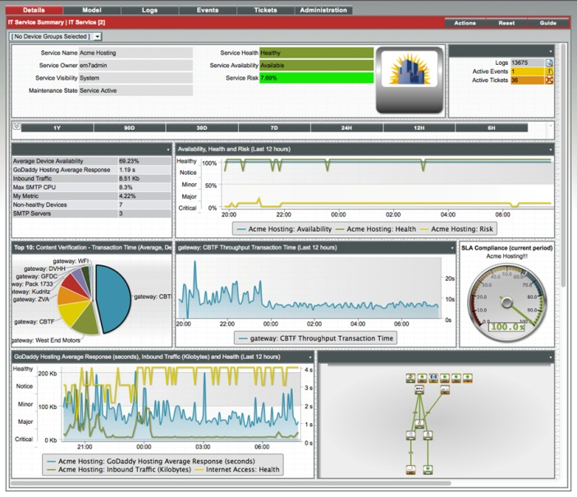  Monitor in Detail {include appropriate detail}  - Servers (Windows, Solaris and Linux OS, Citrix Xen, VMware host and virtual servers)  - Storage  - Applications (Active directory, SAS, SAP, Exchange, SharePoint)  - Databases (SQL, MySQL, Oracle)  - Connectivity  - DNS  - Network  - Hardware asset management and support  - Environmental data of the data center  - Storage (EMC, NetApp, EquaLogic)
 | {Your Company Boiler Plate}

